Excel tips for CEE 453

Topics

Dependency

Names

not burying numbers inside equations

creating well formatted graphs

Spreadsheet demo
Merge two data files
Save as Excel file
Rename sheets
Create analysis sheet (discuss workbook organization)

How could I create a standards graph?
How could I calculate the concentration of the sample?
How could I get a table of concentrations and absorbances at a particular wavelength?
How do I do this if I want to be able to adjust the wavelength?

My solution:
Create a cell with the desired wavelength in it.
Name the cell

Standard concentrations =INDIRECT(ADDRESS(2,ROW(),,,"standards"))

Name the columns containing the data from the standards as std.
Standard absorbances =VLOOKUP(wavelength,std,ROW())

Now create a graph
Line vs xy
Connect the data points or not? What does it mean to connect the data points?
Add a curve fit
Fix the background
Fix the y axis zero (discuss axis labels that are in the middle of the plot)
Eliminate the graph title (captions go under the graph in Word)
Eliminate the box around the graph

Insert the graph into Word (standard paste)
With graph selected, insert – reference – caption
Insert reference to figure in text.

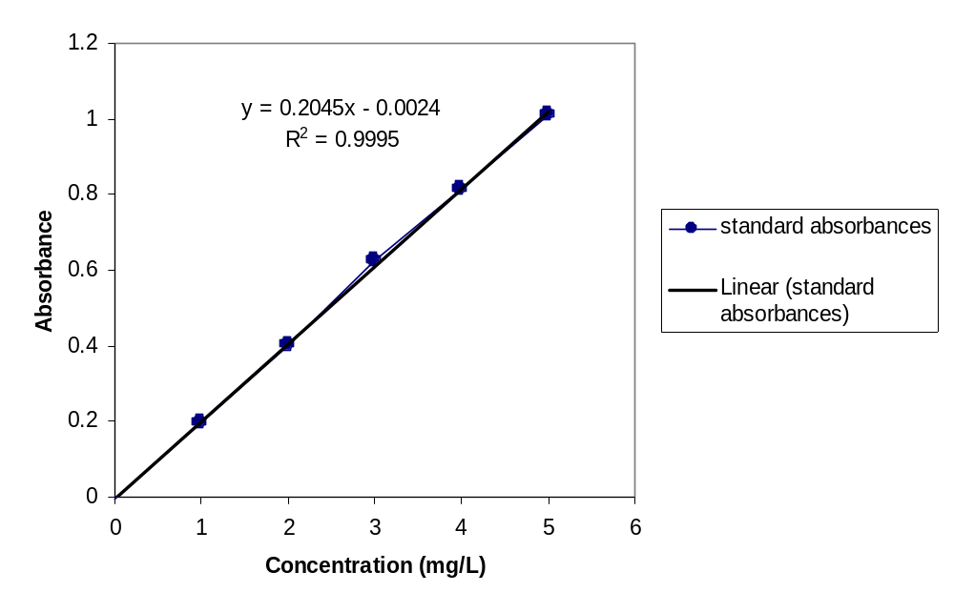
Figure 1 Absorbance of Methylene blue at 660 nm as a function of concentration.

IN the text you have to refer to Figure 2
Figure 2 Absorbance of Methylene blue at 660 nm as a function of concentration.

